**Part 2: Compensated Servo Module Response**

The first section of this part of the lab comprised of analyzing the proportional controller by incrementing/decrementing the gain value. The following plots exhibit the result of the system tracking under different gain values.

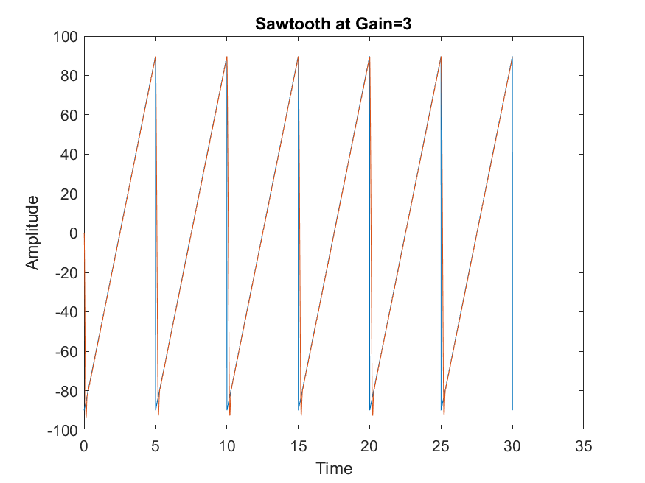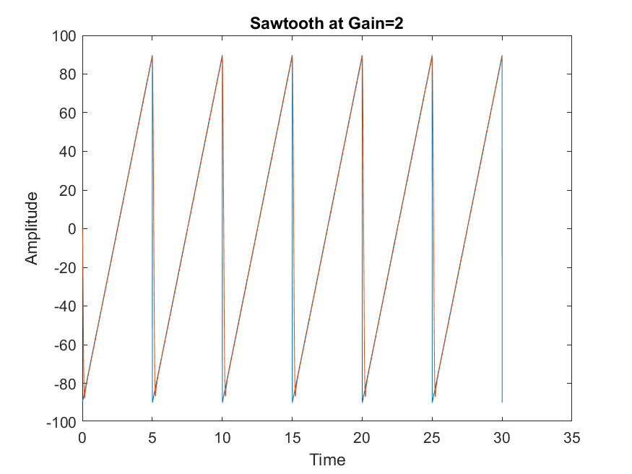

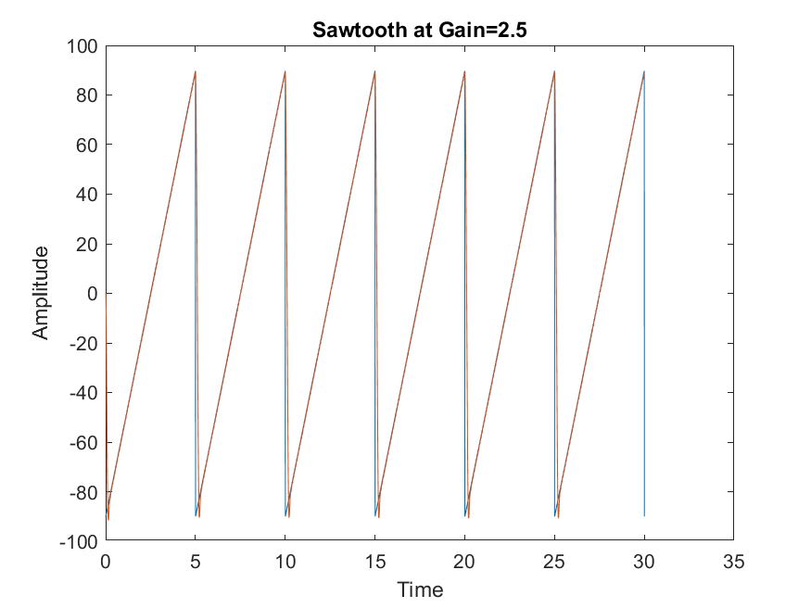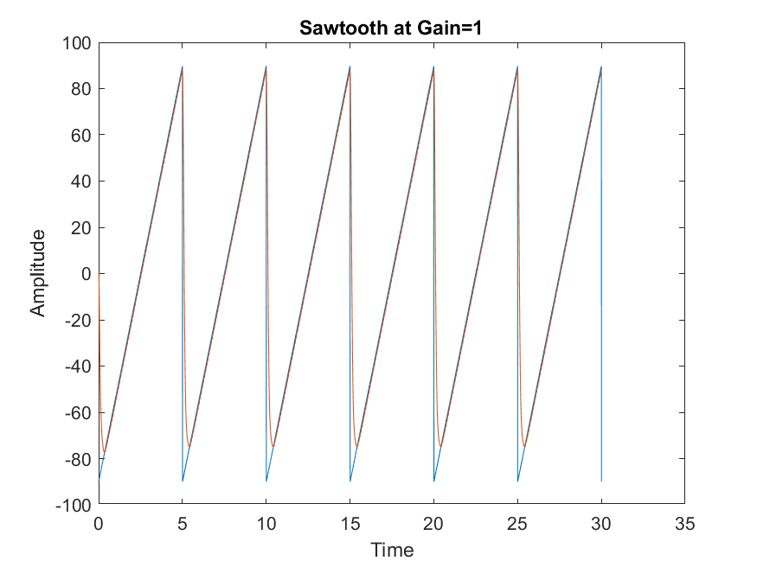**Figure 2.1: Sawtooth at Gain = 1, 2, 2.5 & 3 under Proportional Controller**

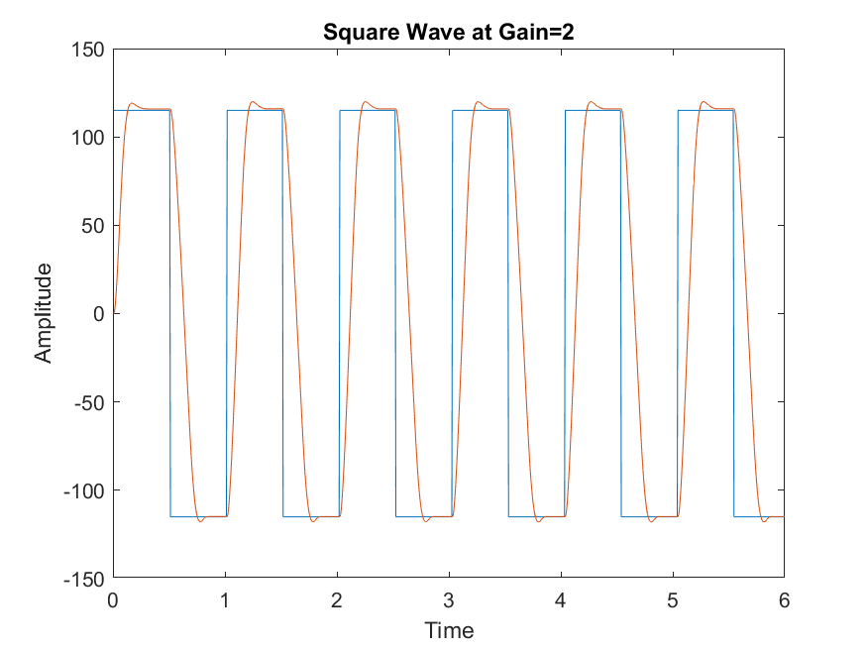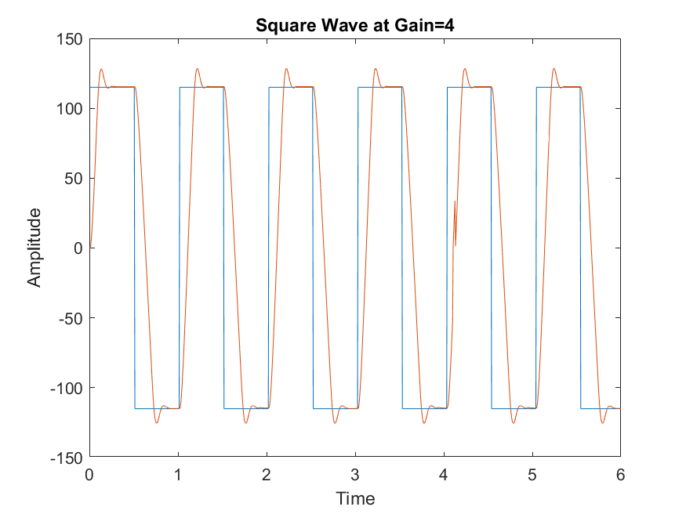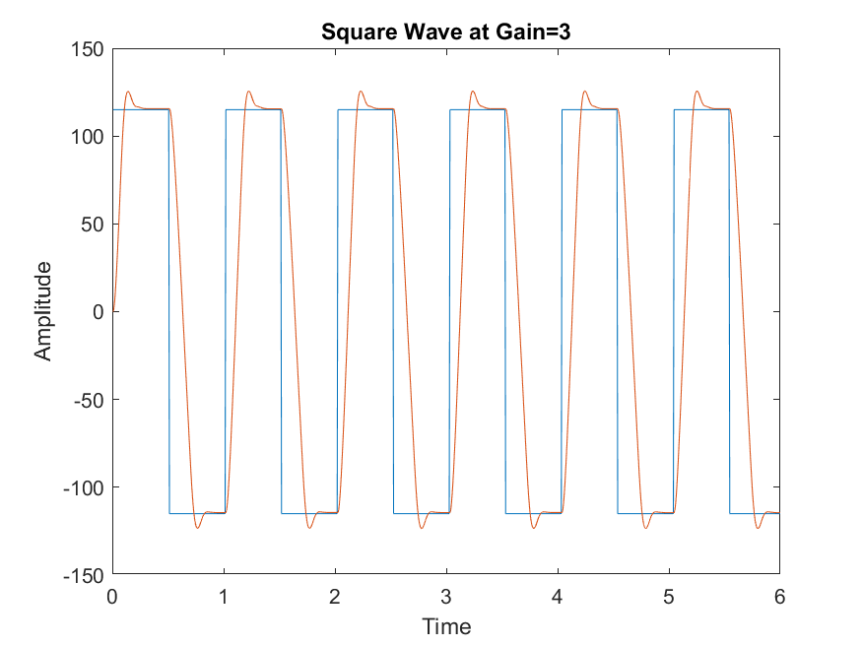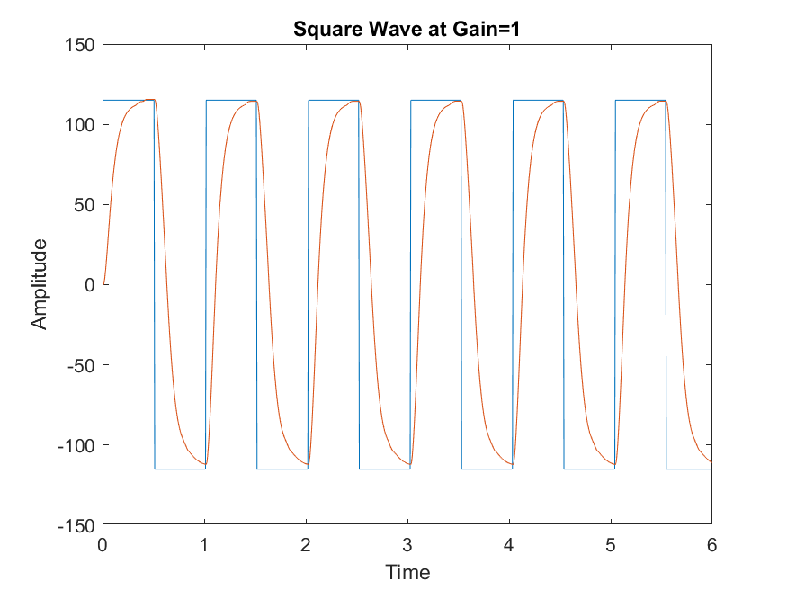**Figure 2.2: Square wave at Gain = 1, 2, 3 & 4 under Proportional Controller**

By observing the plots in Figure 2.1 and Figure 2.2, it seems that the steady state error and the rise time decreases as the gain increases. This also affects the percent overshoot as with an increase in gain, the percent overshoot increases as well. As the system reaches marginal stability due to tweaking of the gain value, the nonlinearities in the system will become evident. Since the system type is 0, the proportional controller was not able to meet all the system specifications. The best value therefore, for the proportional controller was taken at gain = 6.

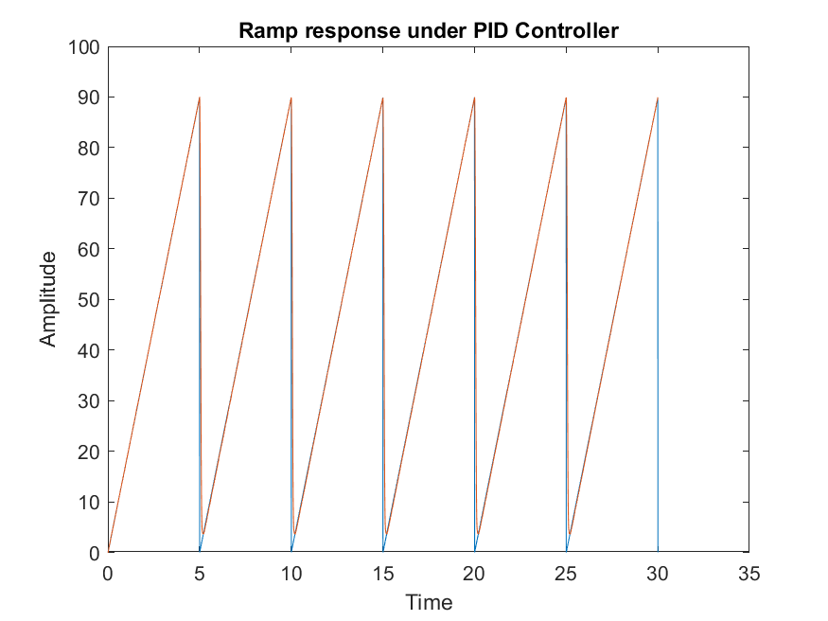

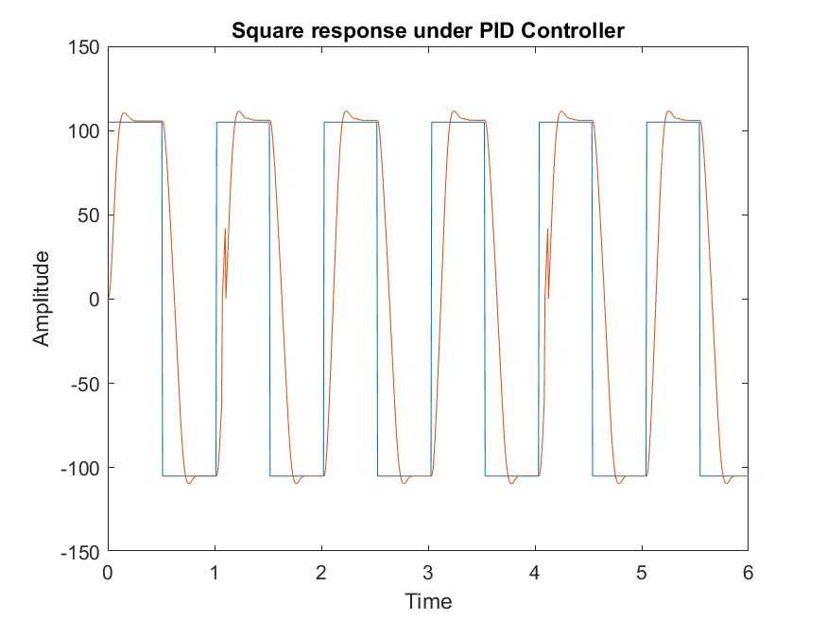**Figure 2.3: Ideal Response under PID controller for both Ramp and Square Input**

The ideal response for both the ramp and the square input were acquired via trial and error. Implementing the PID+A controller led to the conclusion that it was quite like the PID controller. The integral time and the derivative time constant used were 1.7 and 0.02 respectively.

Discussion:

1. The differences between the Proportional only and PID controller were significant. Unlike the Proportional controller, the PID satisfied the desired specifications in the lab fairly well. The percent overshoot as well as the time taken to reach steady state was decreased in PID. Additionally, the ramp input for the Proportional controller would diverge but with PID, it remained constant since the system now is Type 1.
2. The Ziegler Nichols Ultimate gain method was used to process the PID parameter Kp,Ti and Td using the modified method formulas. The controller had a 115-degree step input, and a marginally stable gain was found that was taken as 6, as shown in Figure 2. The period of oscillation was taken measured from the graph and was found as 0.05 seconds (from 385.40 seconds to 385.35). Using these values, the rest of the parameters were determined for the PID controller using the following equations:

K= 0.6Ku Ti = Pu/2      Td = Pu/B

1. The Anti-windup controller turns the integrator of the servo-positioning module off to avoid the apparatus to get damaged, as the system is already in the saturation mode. This prevents the percent overshoot to be very high as the transient response initially would be high if the buildup of energy in the integrator can be reflected in the system, due to saturation. Therefore, the anti-winding system caused the percent overshoot to decrease slightly without affecting other parameters. The controller was not in saturation mode during the nominal range was chosen, which is why a small difference in Percent Overshoot is noticed.
2. The final settings that resulted in the ‘best’ response were with gain = 6, Ti = 1.7 and Td = 0.02.